11.3.4 Editors - Compositor Editor - Sidebar - Options Tab
Options Tab - Performance panel 1
Render 1
Edit 1
Chunk size 1
OpenCL 1
Buffer Groups 1
Two Pass 1
Viewer Border 1
Auto Render 2

Options Tab - Performance panel

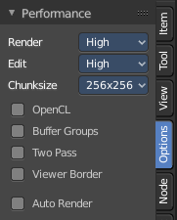
In the Options tab you will find generaloptions. The Performance panel provides you with general settings that improves the performance in the Compositor editor to get faster results.

Render
The quality when rendering the image.

Edit
The quality when editing the image.

Chunk size
The maximum size of a tile. Smaller tiles gives better distribution of multiple threads. But produces more overhead.

OpenCL
Use GPU for calculation. The graphics card must support OpenCL

Buffer Groups
Enable buffering of group nodes.

Two Pass
Use two pass execution during editing. First calculate fast nodes. Second pass calculates all nodes then.

Viewer Border
Use boundaries for viewer nodes and composite backdrop.

Auto Render
Re Render and composite changed layers on 3D edits.

